Create a flow chart of the internet

A flowchart of the internet, is a graphic representation of how data moves through devices to reach the internet, in this case from a personal computer.
How to make your flowchart on the Draw web application
1/ Go to site:
2/ Select save diagram to device
It will save the diagram to the device
(computer, laptop, tablet, phone)
you are using.
It also means if you leave the site
without saving, you have lost all your work.

3/ Select title, file type and template type
Give it an appropriate title and leave it as an .xml file type, so that you can reopen it later and keep working on the diagram. The Draw program can read .xml file types. Select a basic diagram template
4/ Select icons *
Select the different labels in the left menu to see the shapes and icons available; there are many, even a special arrows menu.

*a icon is a representative symbol
Use the search bar to find certain icons

5/ Place icons:
Click on the desired icon to appear in the diagram and drag into place.
Use the turn arrow on the icon to twist direction.
Right click to delete icons.
6/ Style icons:
Use the menu on the right to style the icons.
You must have an icon clicked for this to appear.
Click on the icon and drag its corners to change its size

7/ Add text:
connected to an icon
When you have an icon selected, you can attach text to it. When you rotate or move the icon, the text will move with it.

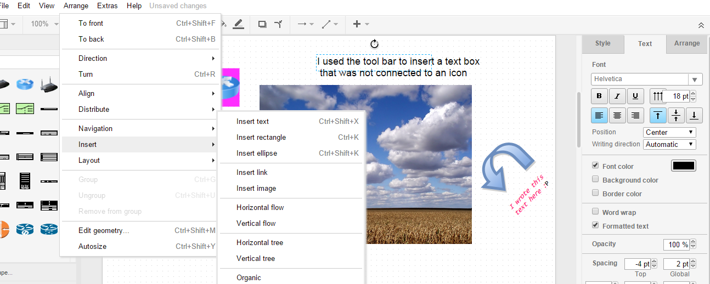
Text Box:
Select arrange on the top menu, then insert , then insert text, to add a text box.
The shape of the text box will be decided by how you type the text box (press enter for a new line).
When you are in the text box use the tools on the right menu to change the size, colour, text type.
The text box can be moved later.

Paper format:
Do you want your diagram to be wide (landscape) or tall (portrait)? Select the appropriate format on left menu, when you are clicked on the white background. The menu will not appear when you have an icon selected.

Move images and text forward:
Use the icons on the top menu to make selected text or icons move behind or in front of other icons.

Save as to keep working on it:
Select from top menu, File, save as, and make sure you know the name you give your diagram. Select save to device. This will save it to the download folder on your computer.
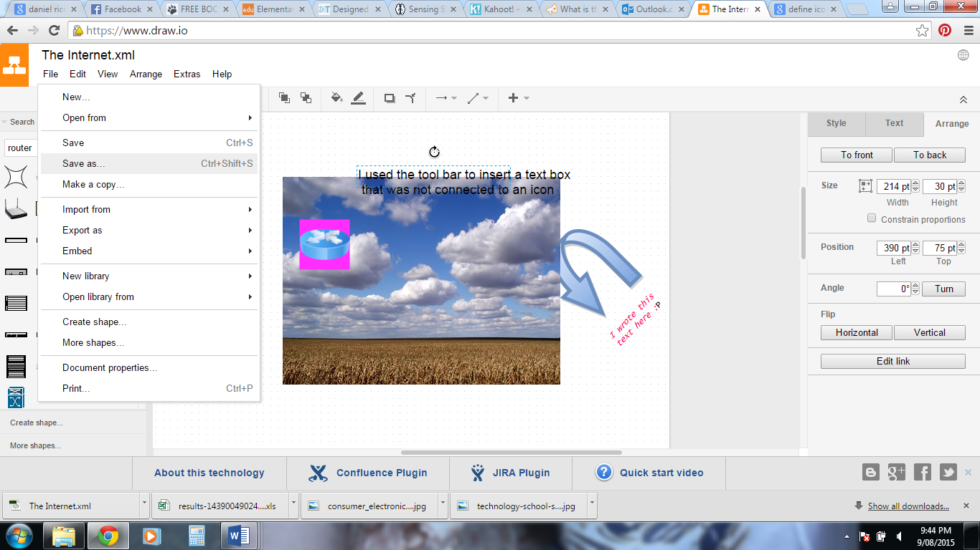

Find it by going to my computer and to the download’s folder and looking for the latest (date modified) or its name.
Move the xml file into your account before you log off the computer
You will need to move it from the download’s folder into your personal folder. Copy from downloads, open your folder and paste into it.
To work on an already saved diagram (.xml file)
Select open existing diagram
Find it in the folder you saved it into or use the search bar and enter its title.

IMPORTANT:
When your diagram is complete export it as a file type that can be viewed outside of the Draw app
Once you do this you will no longer be able to change or open it in the Draw app, but you will be able to view it outside of Draw (.xml files can only be viewed inside Draw)
Select File from top menu. Select export as JPEG. Again name it logically and it will save it into the download folder, where you will need to move it into your personal folder.

Hint: If you need assistance with your spelling and grammar
Open a Open Office Writer document and type into that first, make corrections and then copy and paste it into the open text box in Draw.

